Maskdraft: Fuel Application

Firat Bostan – 1133853 -- Project leader

Dominik Marino – -- SW - Architect

Emre Bostan – 1136658 -- DB – Administrator

An application, that gives an overview about the expenses for the different kind of fuel

Login:

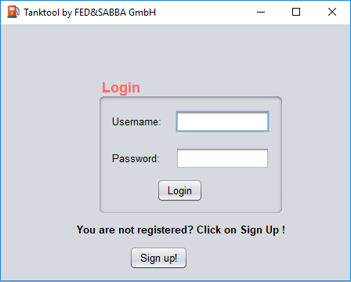

Login or creating account

The User can Login or create a new account for the application. If all entries in the textfield correct, so the user get a request from the program that everything is ok or if the insertion not correct the user get a message username or password is not correct. You can also creating a new account.

Account attributes:

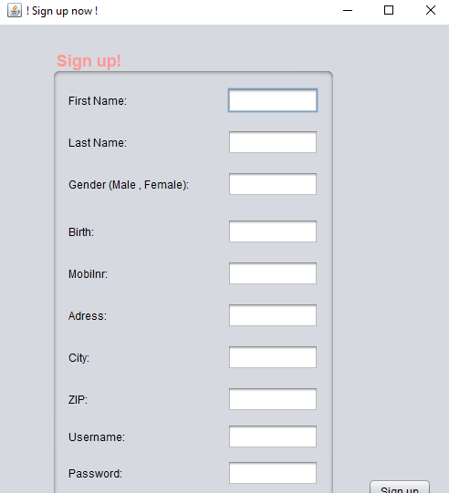

Data of account

The user need to fill every textfield, if there is a empty field the user get a message that he/she should correct it. Also the user get a message that the username is already taken.

Car attributes:

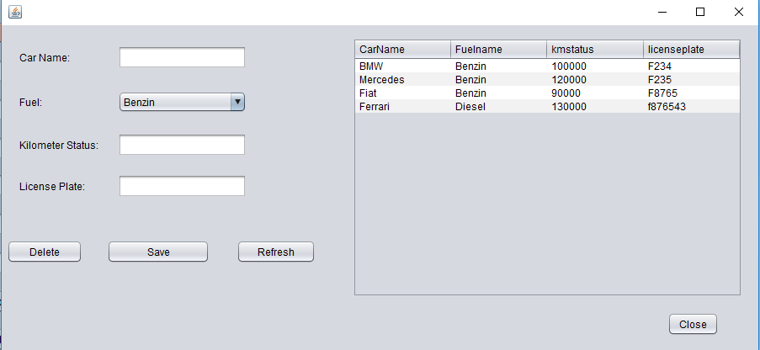

Delete or sava a car in database

Table oft he car fleet

In the window of the cars, the user can see all the information of the car and also can insert a new car in the car fleet. The user can also delete a car from the table. After that a insertion or a deletion the user can refresh the table and see a updated table.

Main of the Application:

See all cars from user

add/delete a car

See all cars

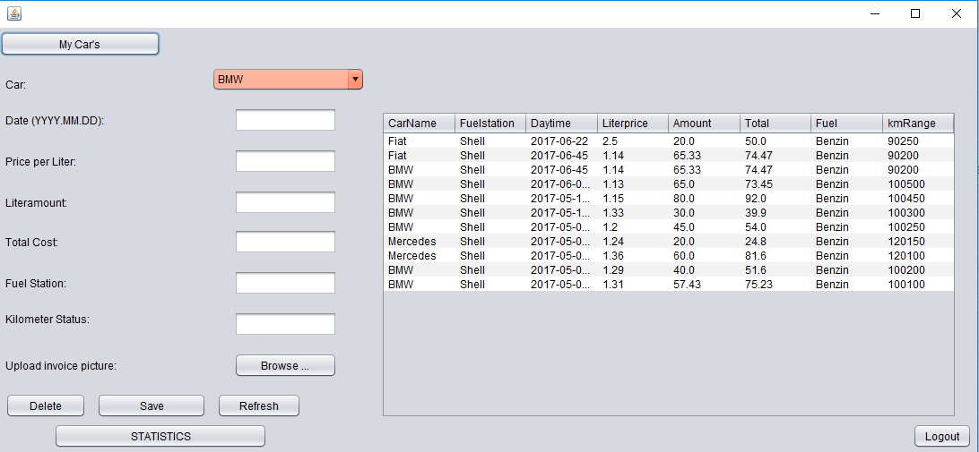

Add/delete stop from database

Logout from account

On the left side the user can save a new stop, delete a stop and also refresh the table.

In the table all entry are sorted by the newest entryies. So if the user want to delete something of the table you need to write all information into the textfields and push the delete button.

The user want to edit a new stop you need to fill the the textfields and choose a car from the combobox and push the save button.

There are buttons for logout, see all cars and a button for statistics.



Data analytics:

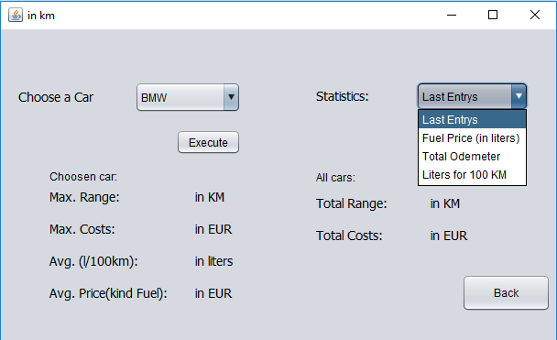

Choose/set car and you ge all important inforamtion about the car

First of all you can choose a car from your car fleet and execute it. The information will fill it automatically in the labels. The user can also choose a statistics and push execute and then it will open a new window and you can see the chart.

Last of all you can get back on the main window if the user click on the back button

Example Chart:

Example of the chart

